**CAPSTONE PROJECT**

***Environment Setup on Linux Machine:***

**AWS CLI**

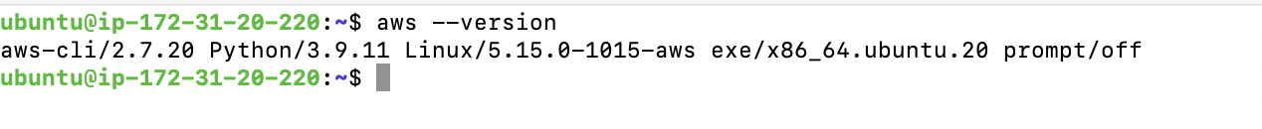

**Terraform**

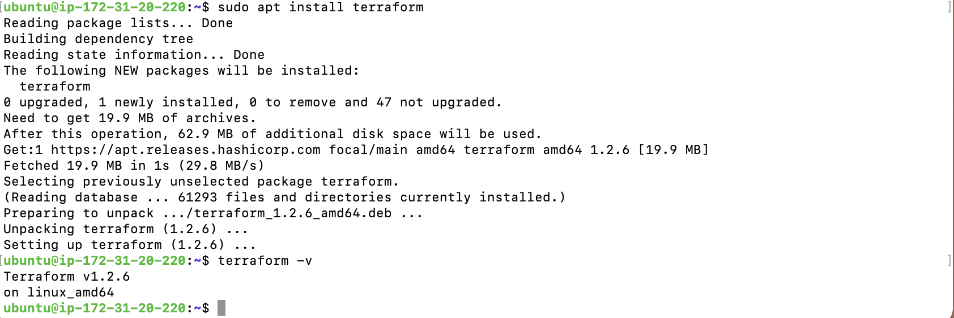

**Admin Access to the Linux machine**

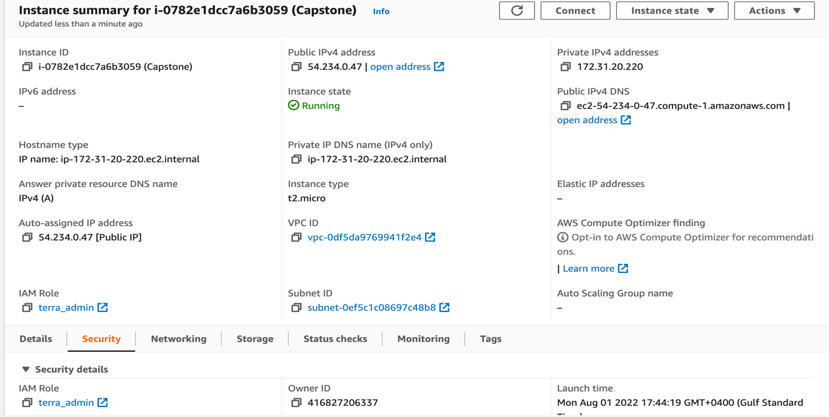

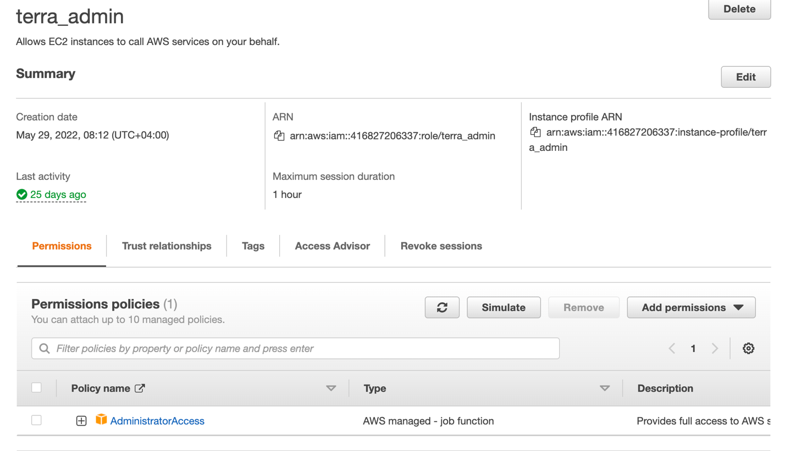

**EKSCTL**



**KUBECTL**



**DOCKER**



**HELM**

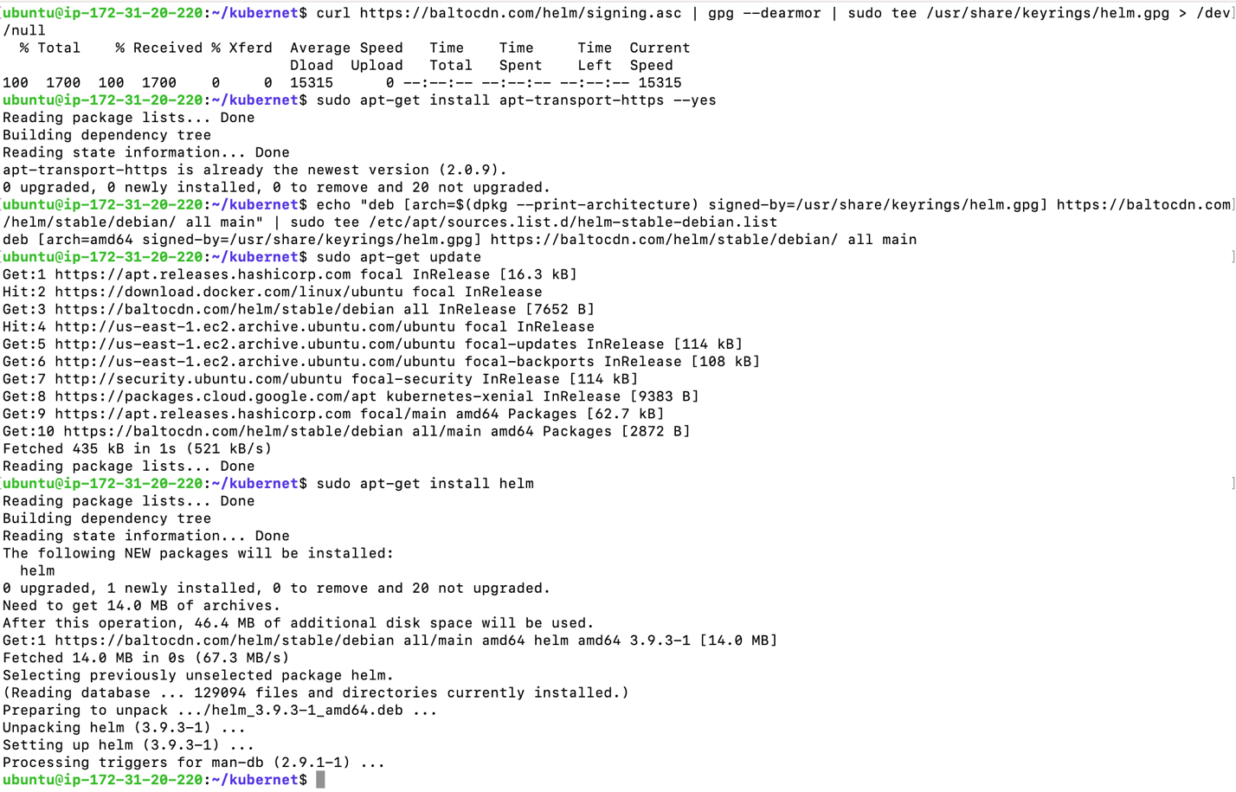

**Apache Benchmark**

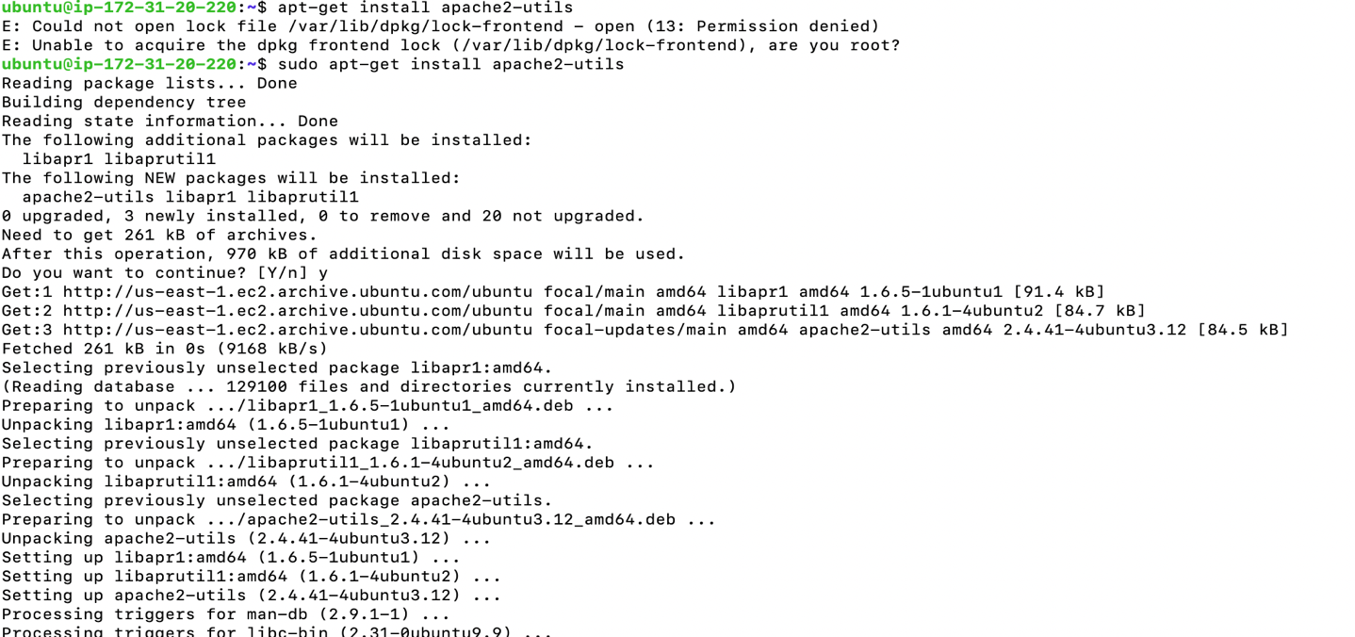

***EKS Cluster Setup:***

**Initialize a bucket in s3 for a backend state store using Terraform**

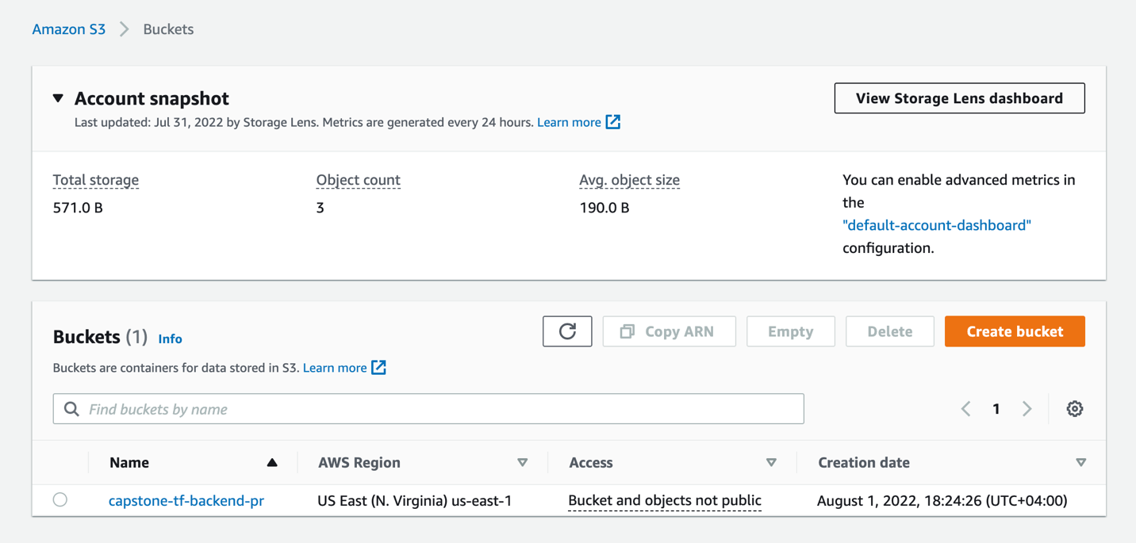

**Create AWS resources using Terraform:**

Files used for creating AWS resources using Terraform

1. provider.tf
2. vpc.tf

* AWS VPC
* 1 IGW
* 1 NAT-GW in AZ-a
* Subnets (2 public & 2 private, 1 each in AZ-a &b)
* Route Tables for both subnets

1. variables.tf
2. output.tf

**Terraform Apply**

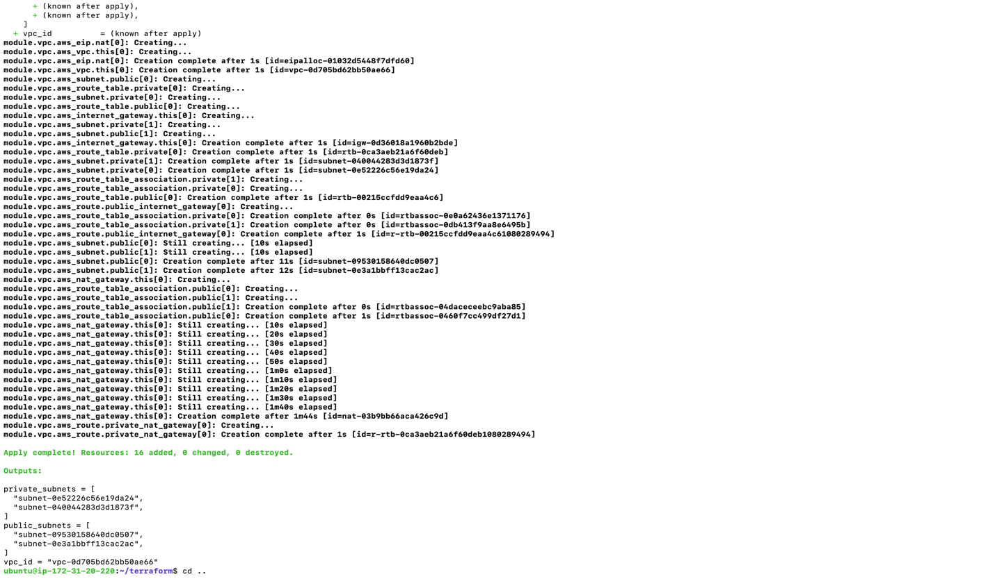

**Creation of EKS Cluster**

Files used for creating AWS resources using Terraform

1. eks-conf.yaml

**Edit the provided config file with Terraform output**

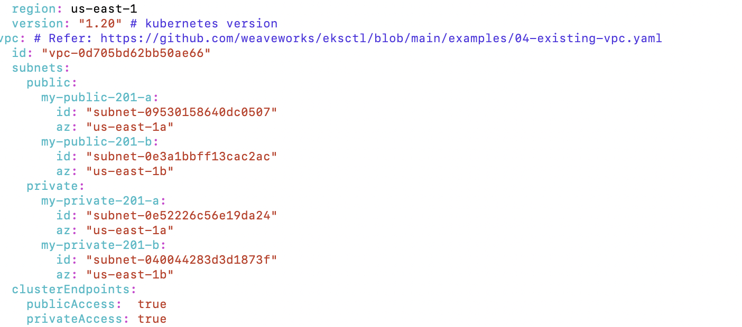

**Create EKS Cluster**

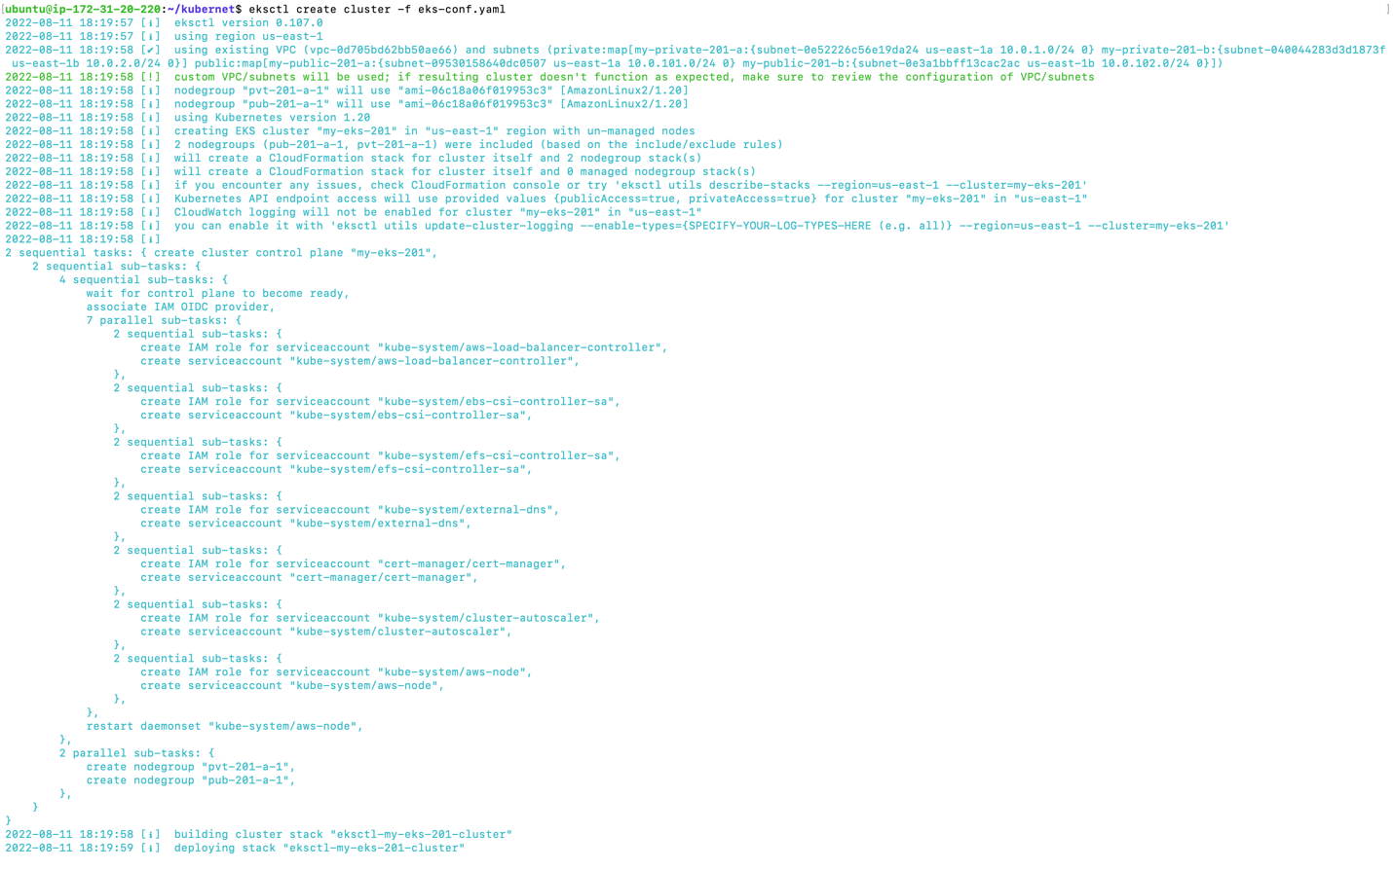

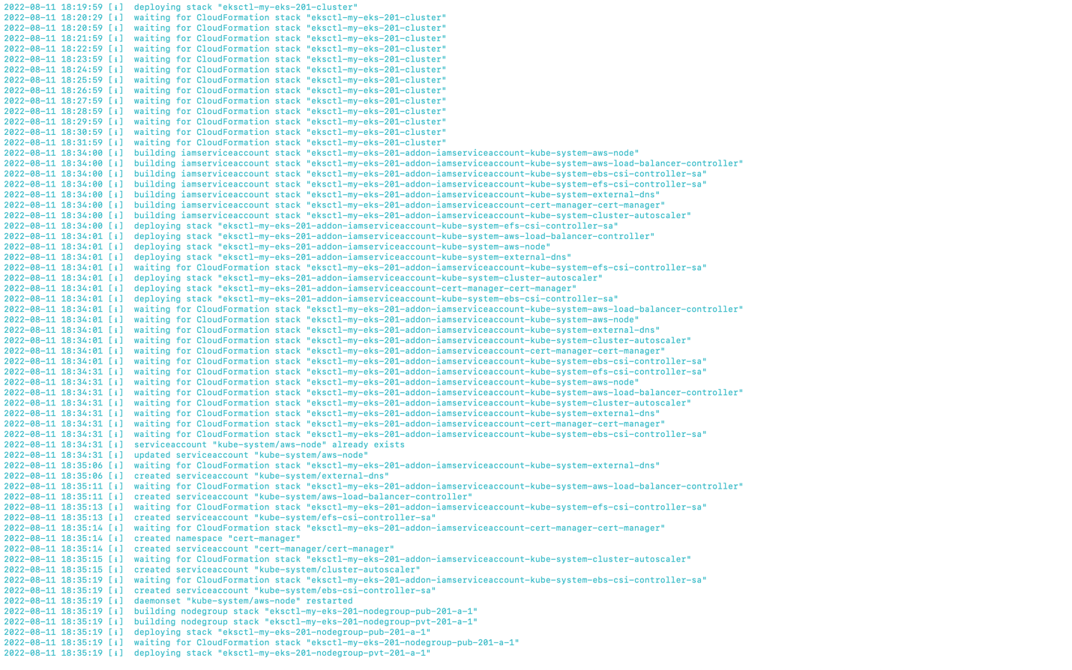

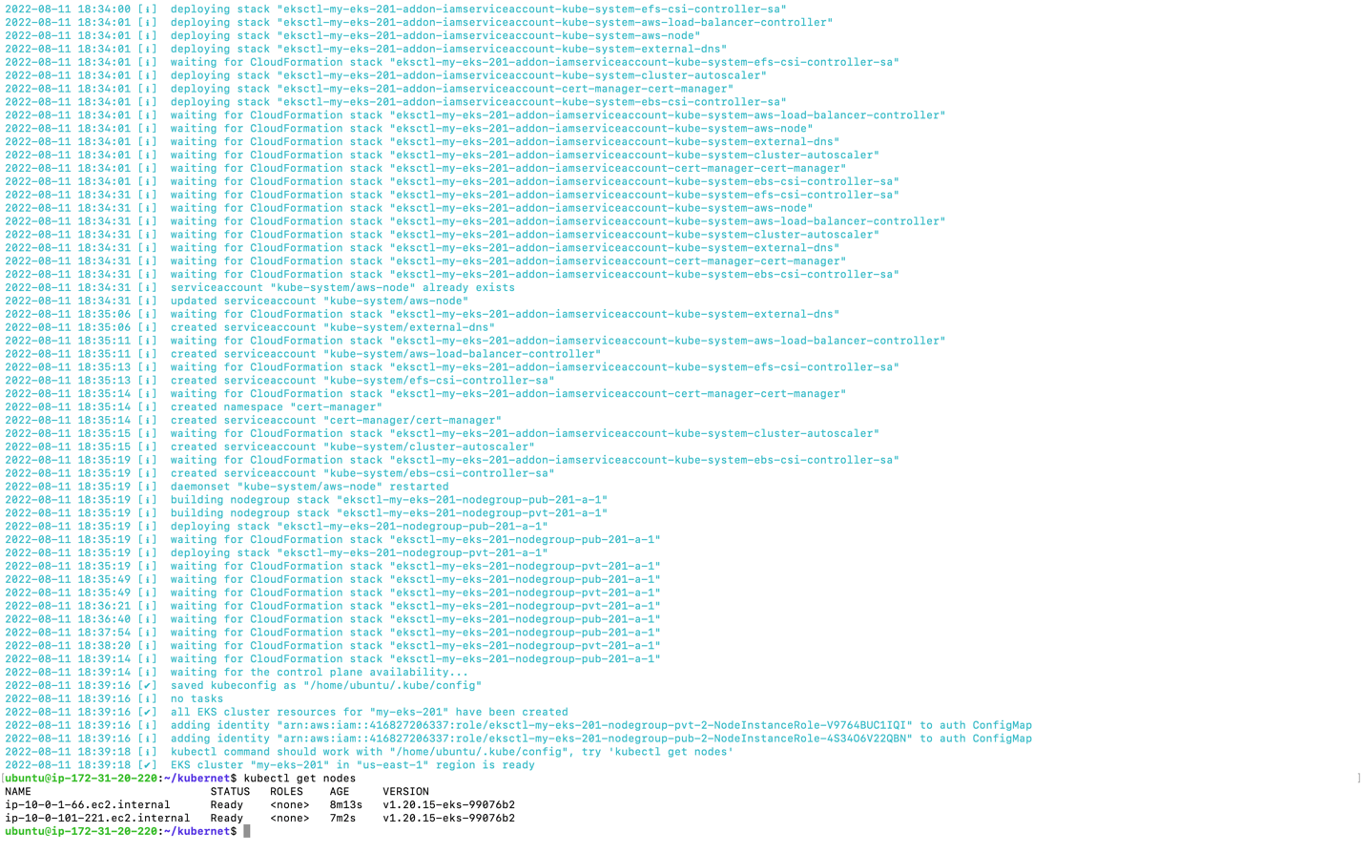

**Nodegroup**

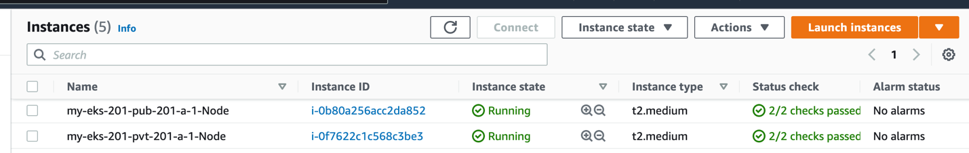

**Install add ons to EKS Cluster**

1. Install Metrics Server

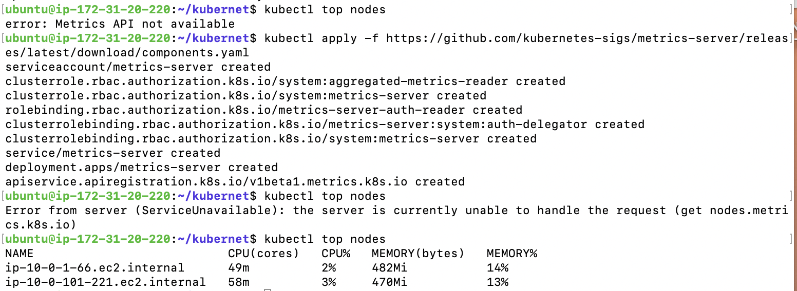

1. Cluster Autoscaler

Files used for creating autoscaler:

cluster-autoscaler.yaml

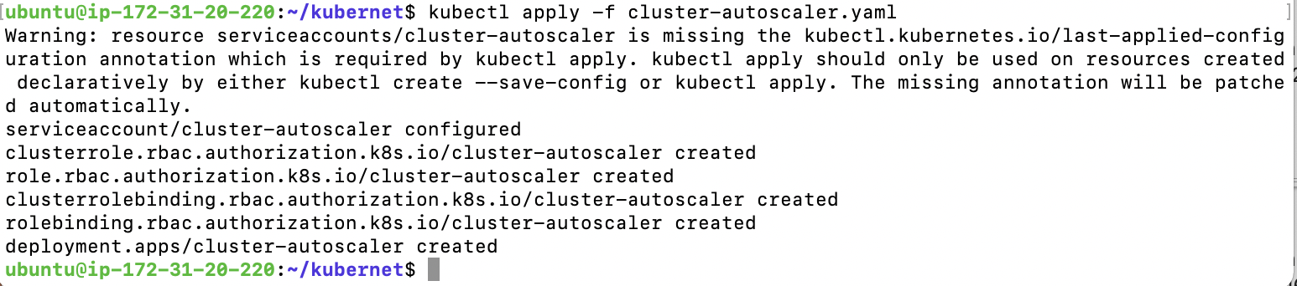

***Deployment of sample application:***

**Create an ECR Repository**

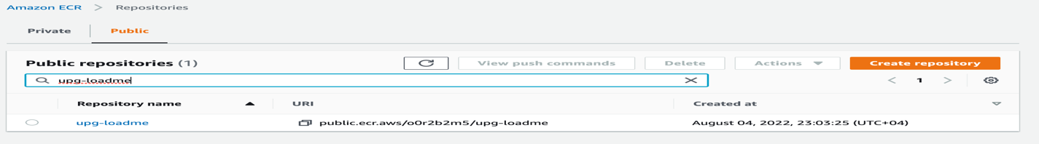

**Write Dockerfile**

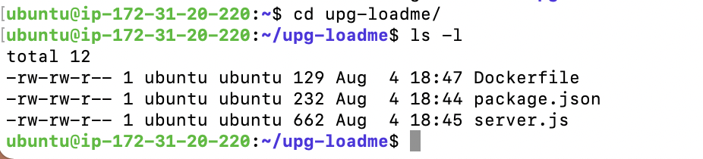

**Docker build and Docker run**

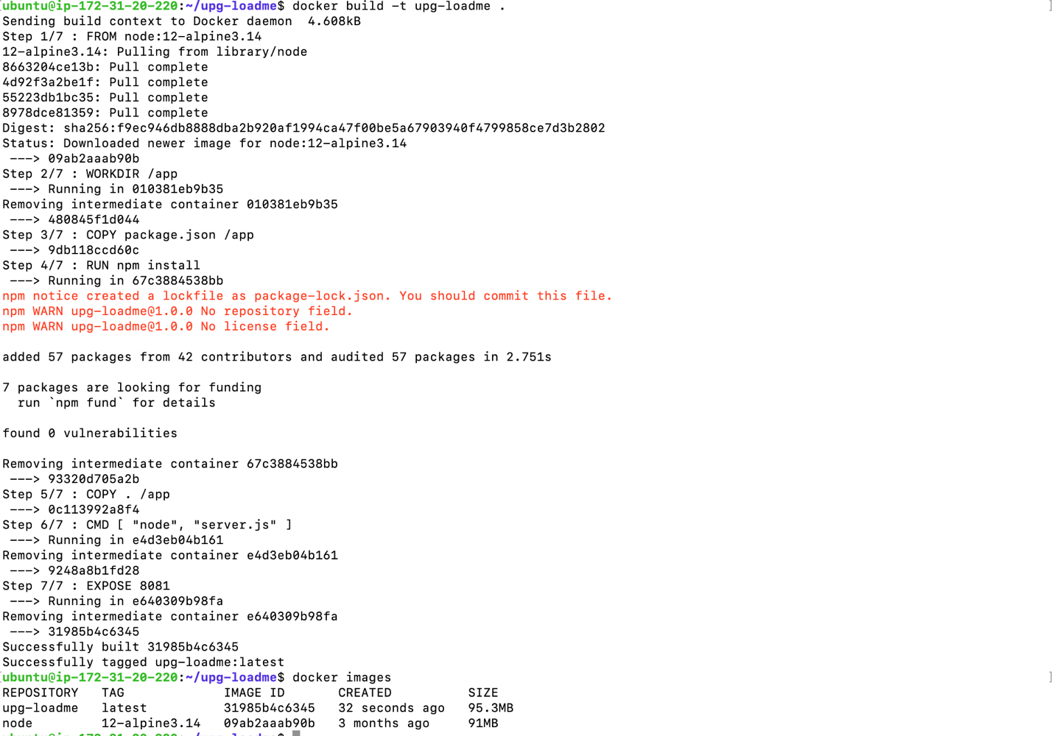



**Test Docker build and run on your local system**

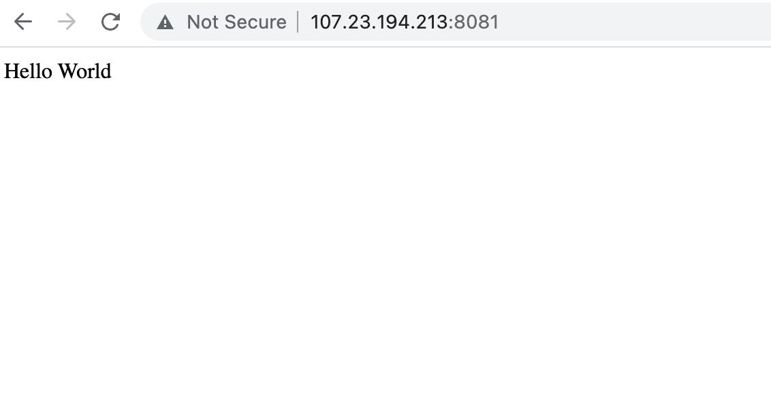

**Tag & push the docker image to the ECR repository**

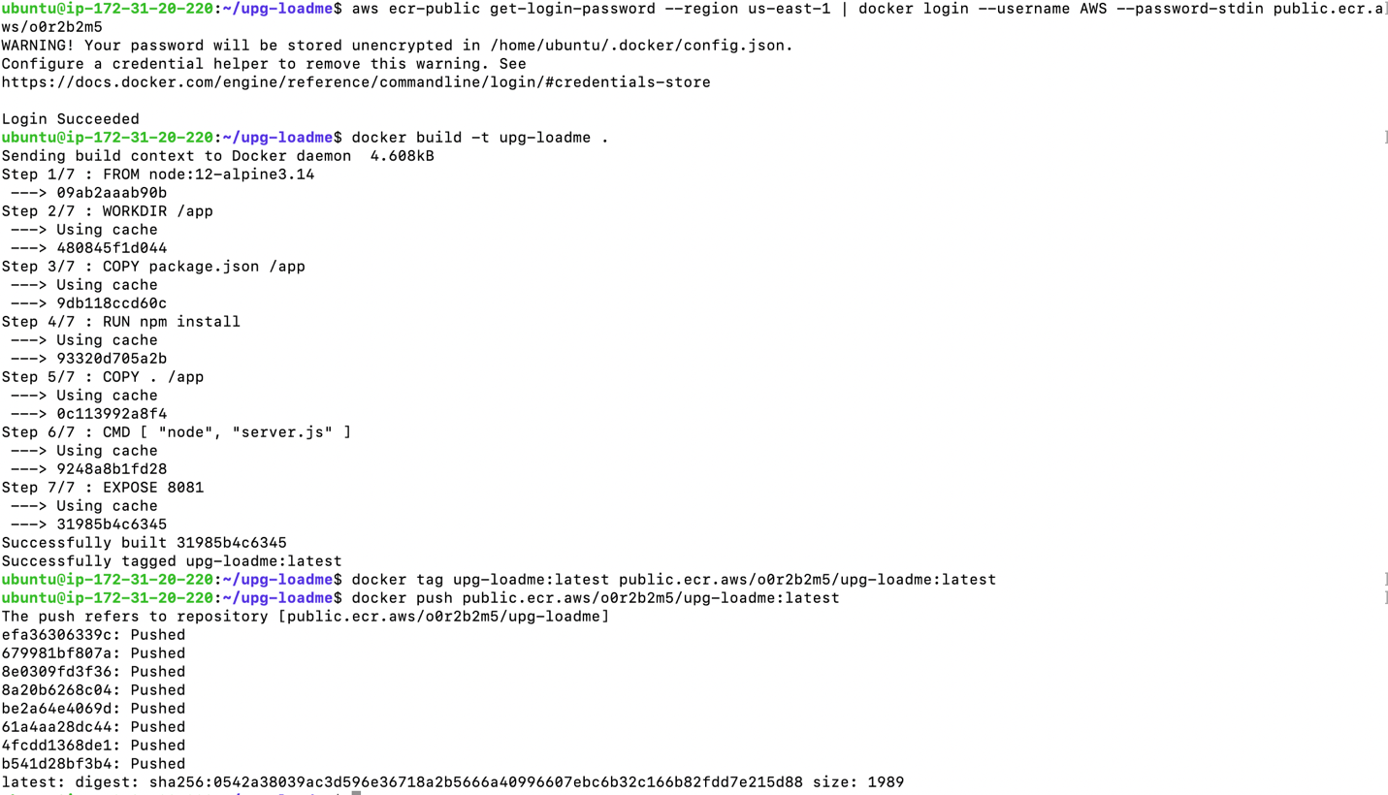

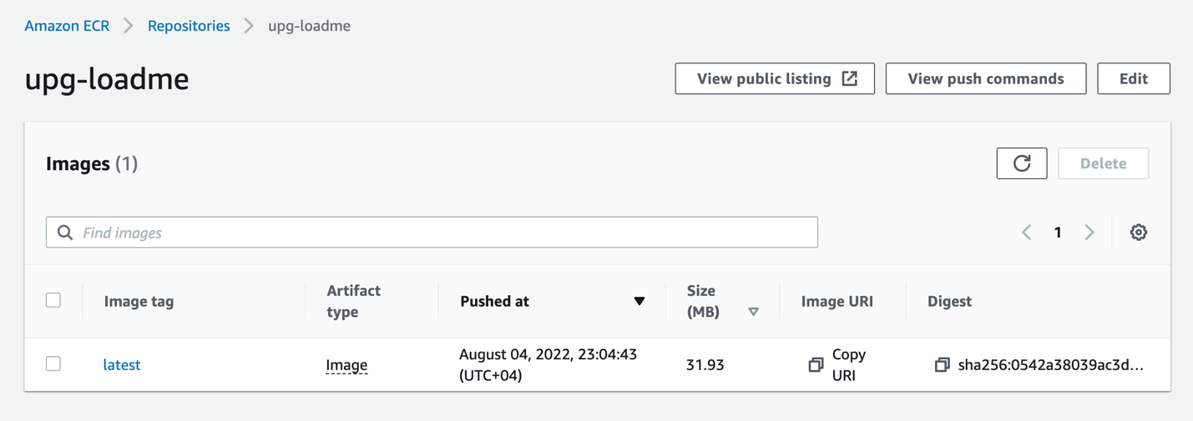

**Create a nodegroup using eksctl which should have a taint on nodes**

1. Taint Configuration

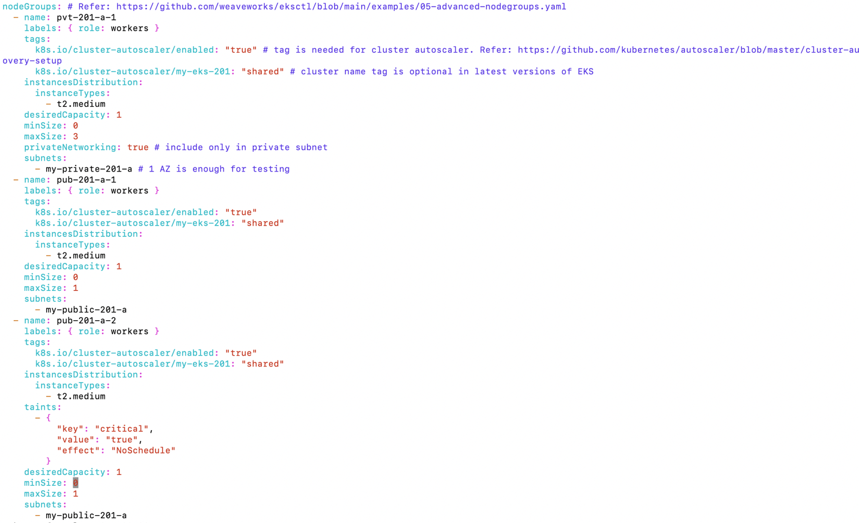

1. Create Nodegroup

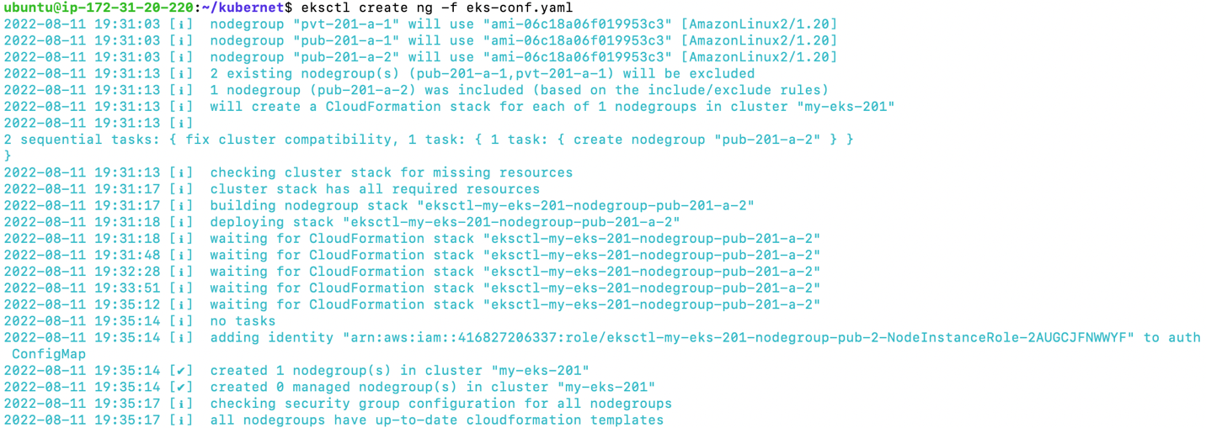

1. Get nodes(taint)

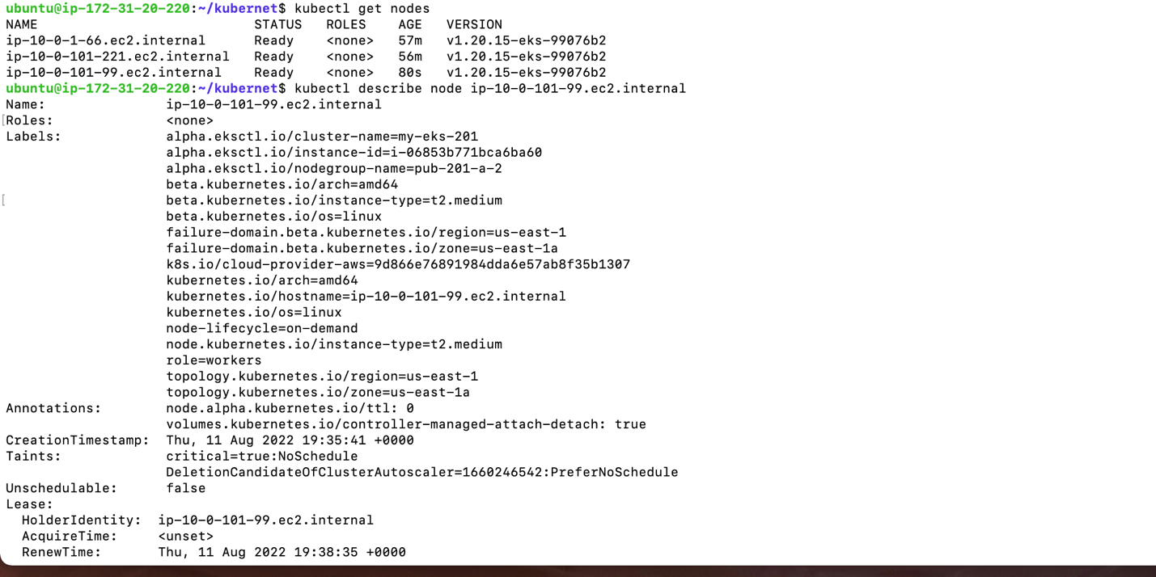

**Deployment of sample application on EKS cluster**

1. Create ‘demo’ namespace

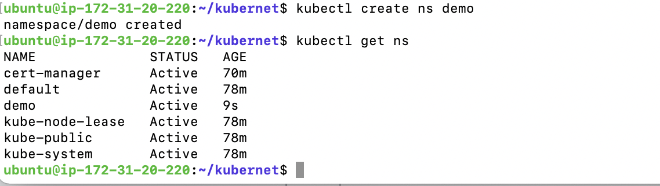

1. Create a Kubernetes deployment & service (upg-loadme.yaml)

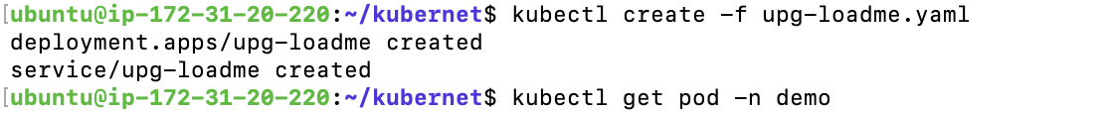

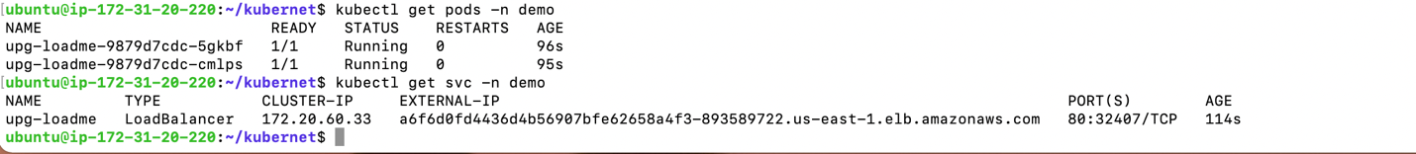

1. Describe pod and service

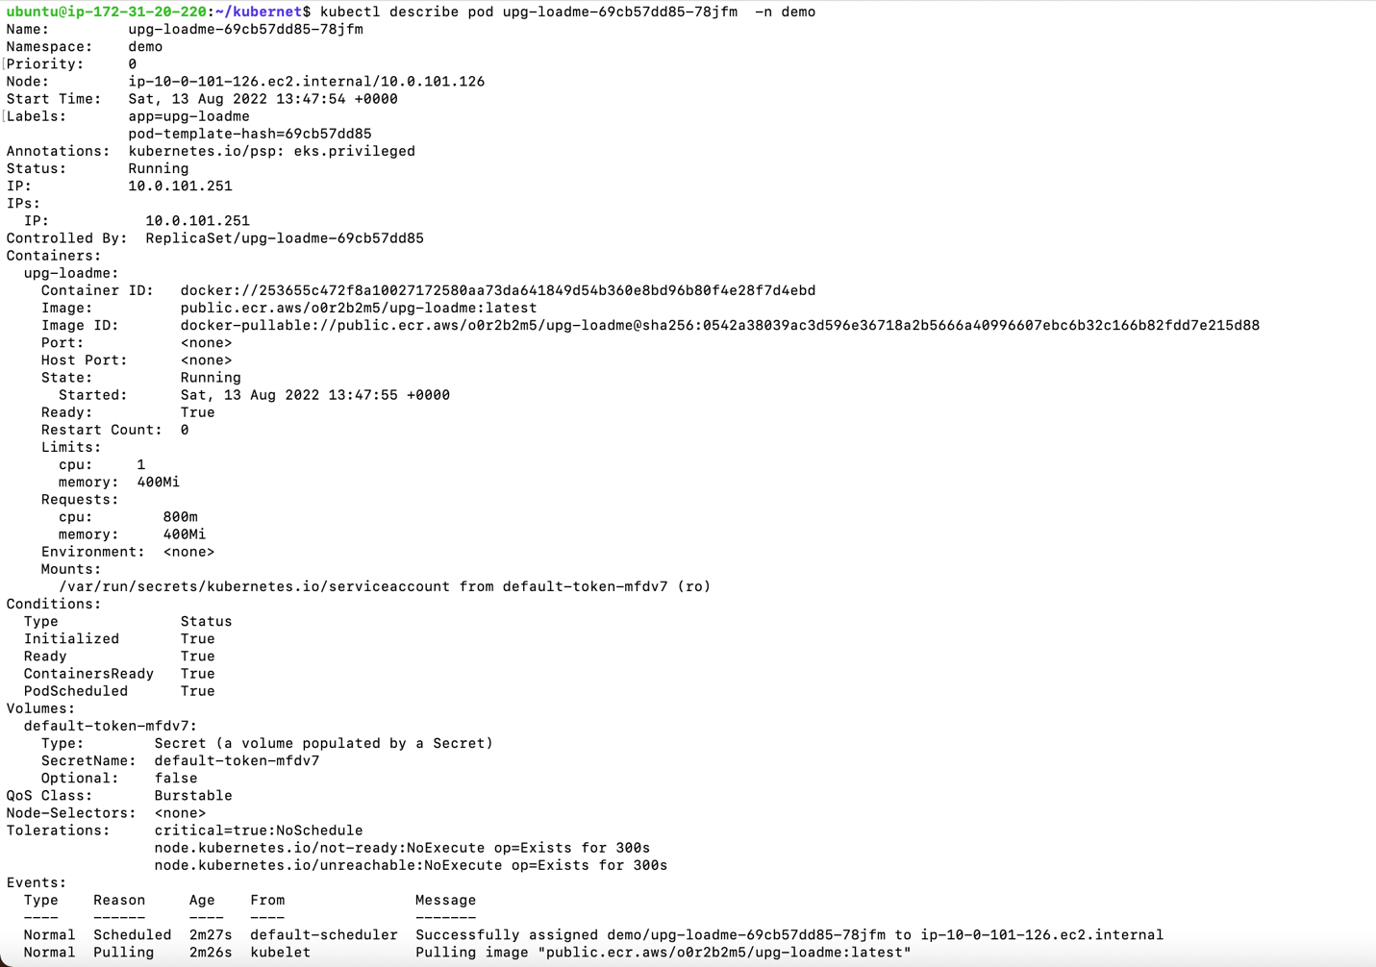

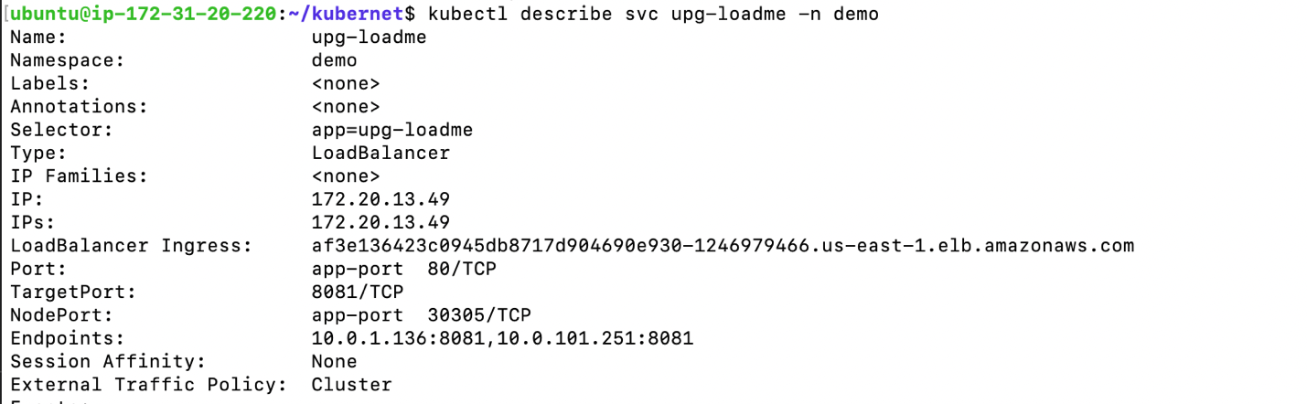

1. Loadbalancer response

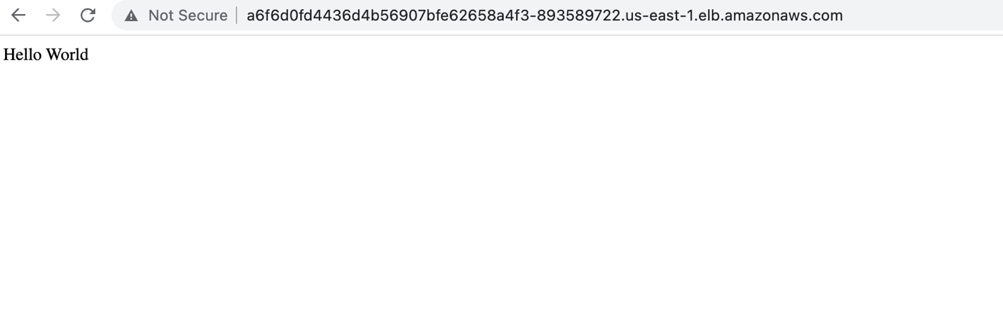

***Deploying a stateful application***

**Deployment of Redis server using Helm having Persistent Volume**

values file – redis.yaml

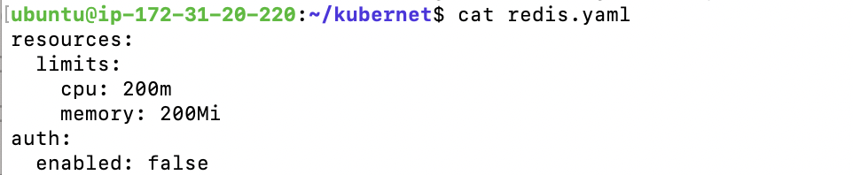

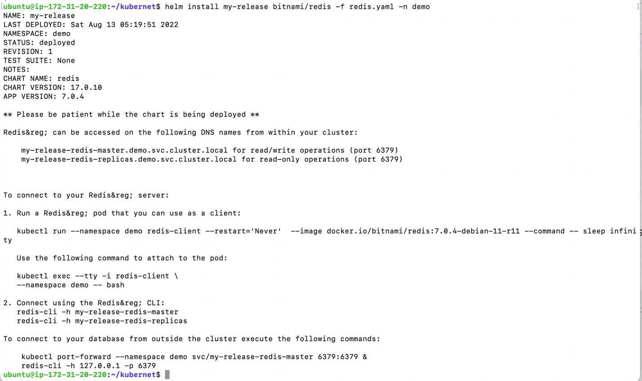

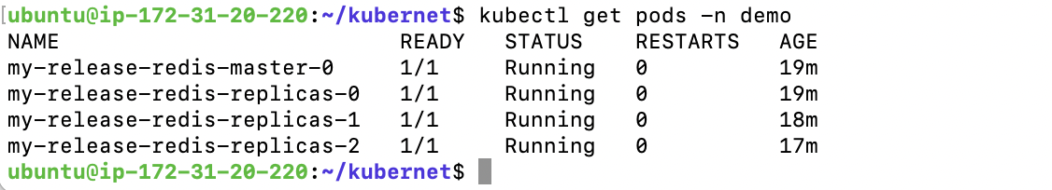

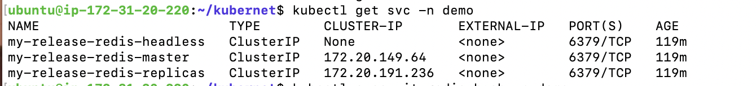

**Deployment of single Redis for redis-cli**

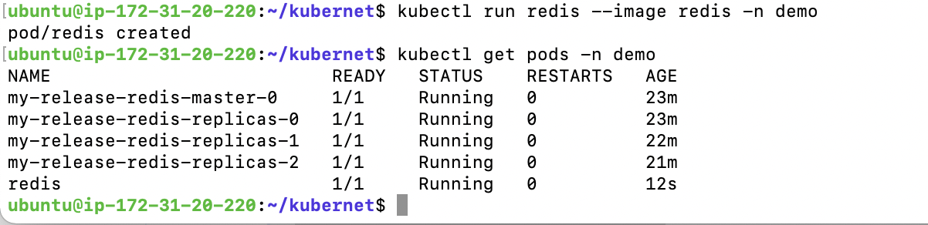

**Exec using ‘bash’ shell into the pod of redis-cli deployment and connect to redis having persistent volume**



**Store key-value pairs on the server**

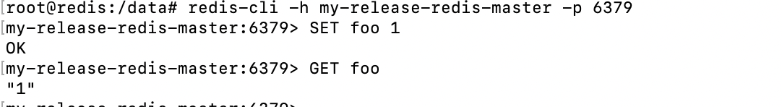

**Delete the pod redis-server**

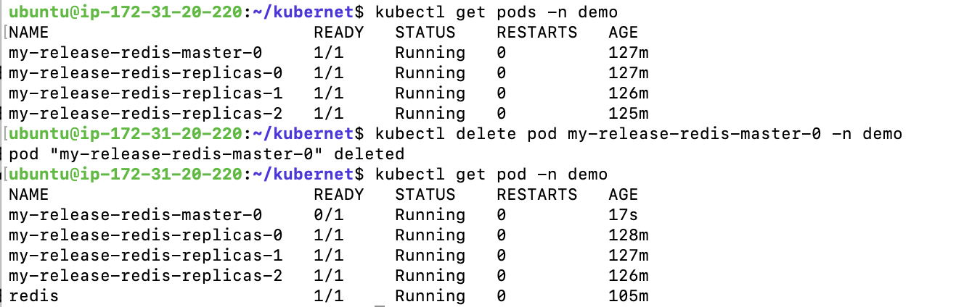

**Once the pod is restarted, reconnect using redis-cli and verify if key-value pairs are present**



***Test auto scaling of the application***

**Deploy an HPA(Horizontal Pod Scaler) for upg-loadme app**

File used to create hpa

hpa-upg-loadme.yaml

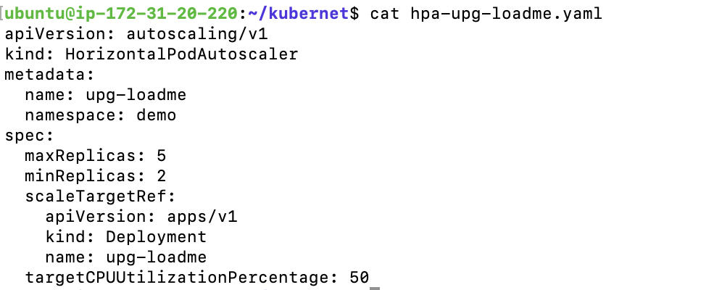

**Get HPA**

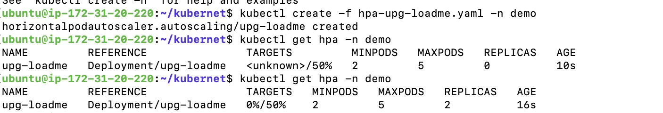

**Install prometheus on the cluster using the official helm chart**

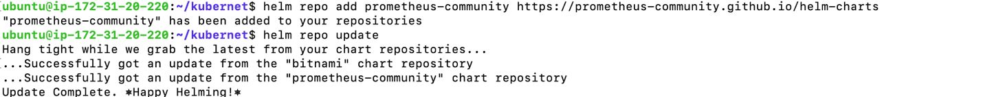

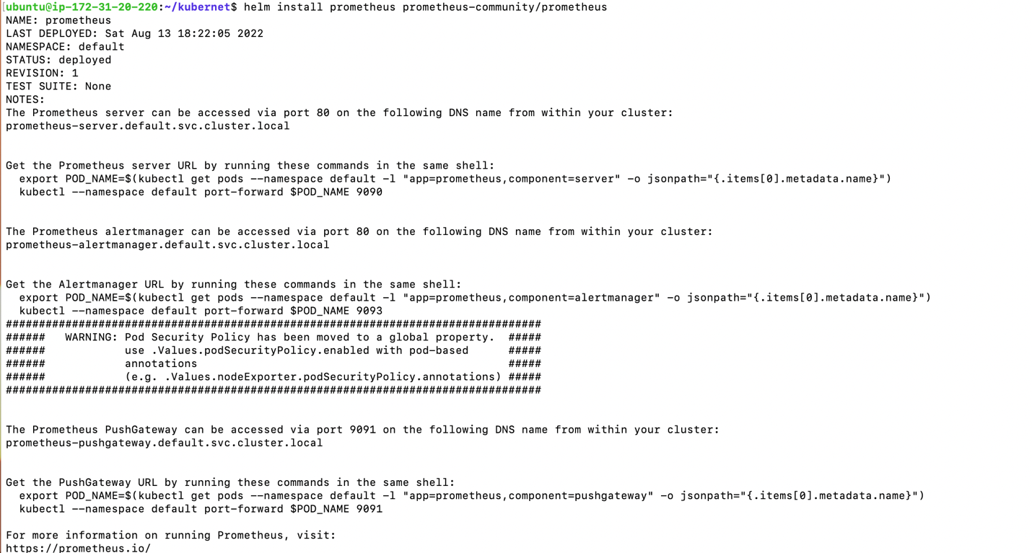

**Get Prometheus pods and services**

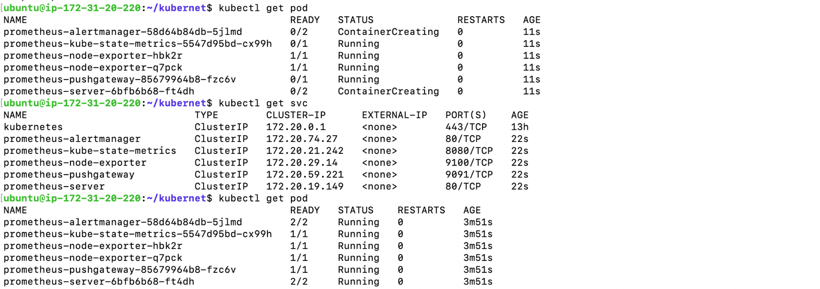

**kubectl port-forward to access the prometheus server from your system via service of prometheus**



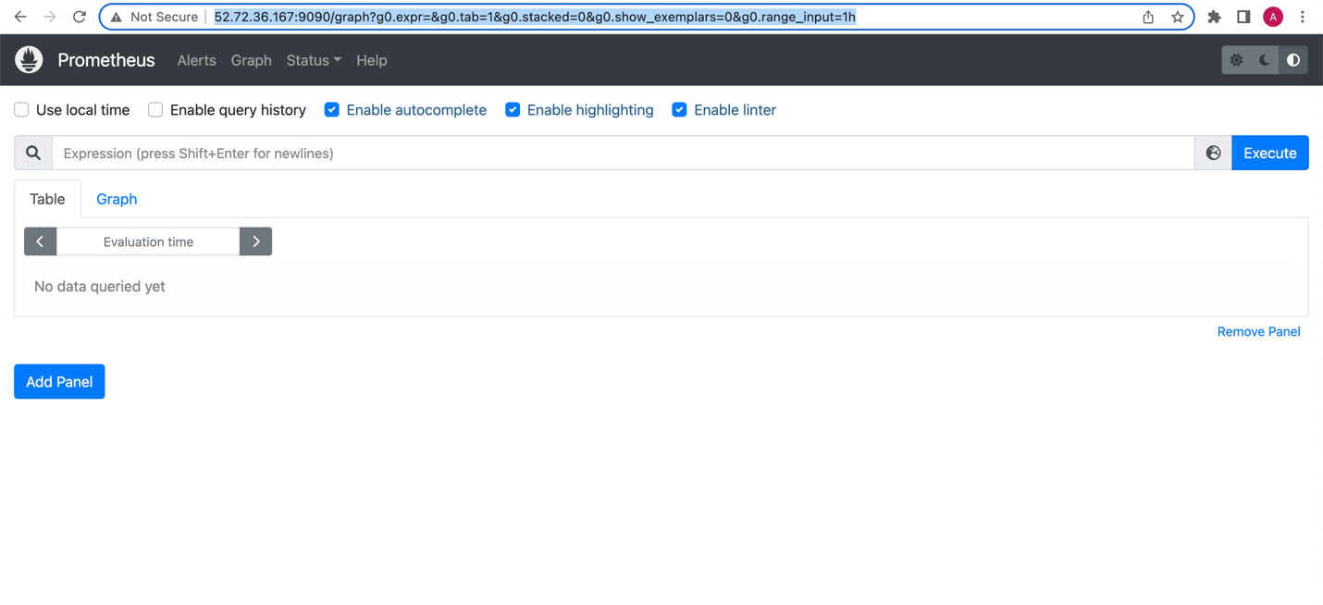

**Generate load on upg-loadme app using ab tool to test hpa**

1. Use ab to hit requests on “/load” api with query parameter “scale=100”

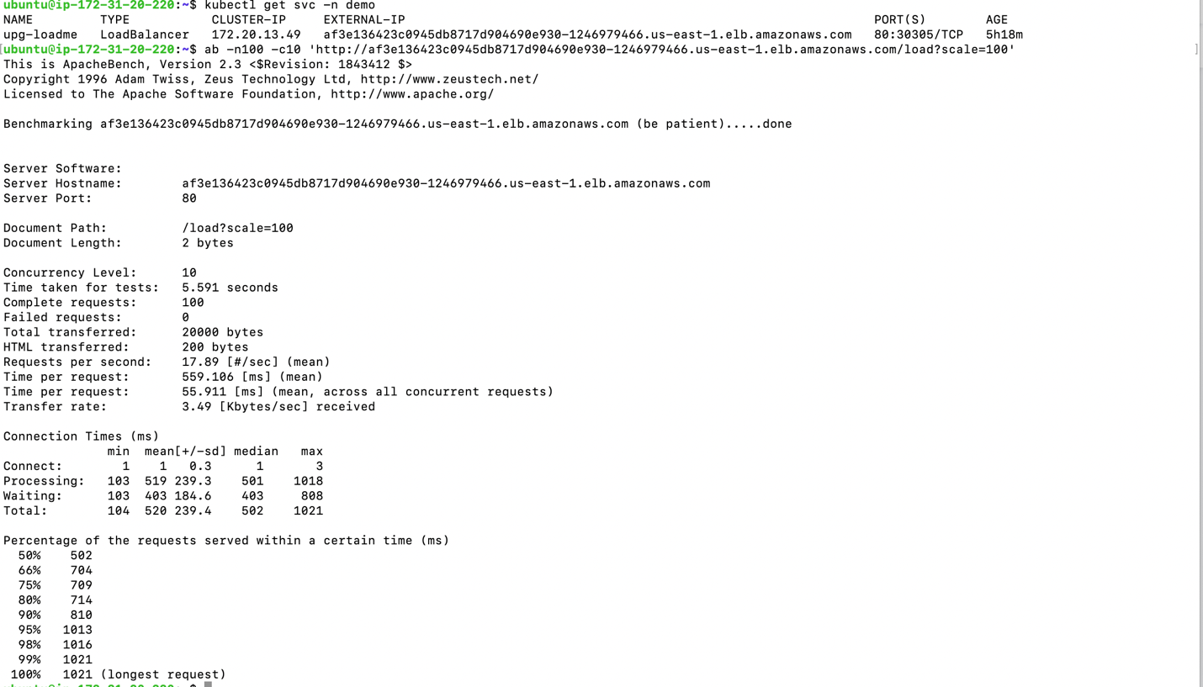

1. Increase value of scale to 300 for higher load per call

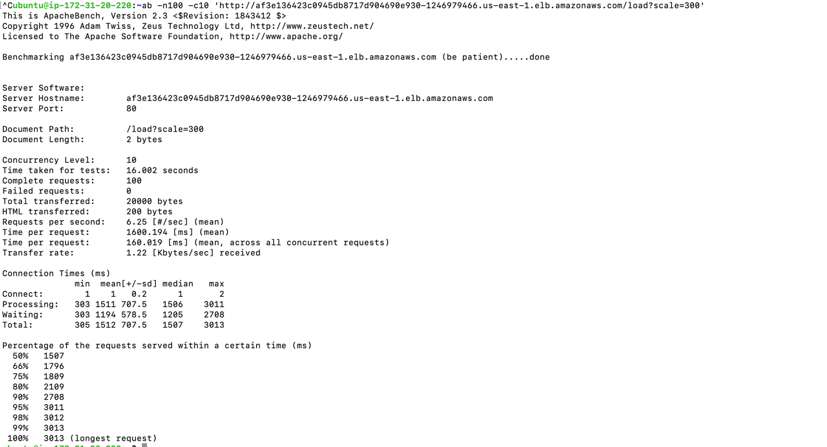

1. kubectl get hpa command to monitor the load on the pods

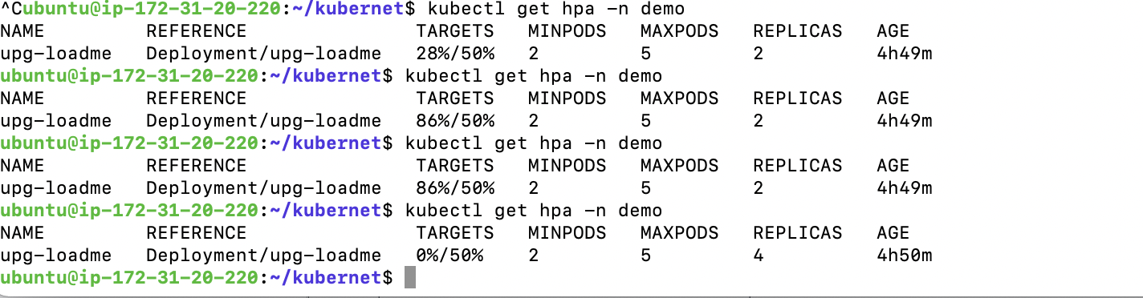

1. kubectl get pod command to monitor the load on the pods

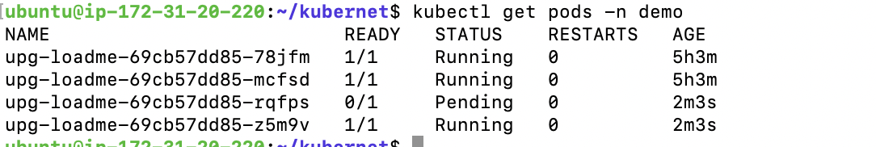

1. Stop load test (ab command) and wait for pods and nodes to scale down

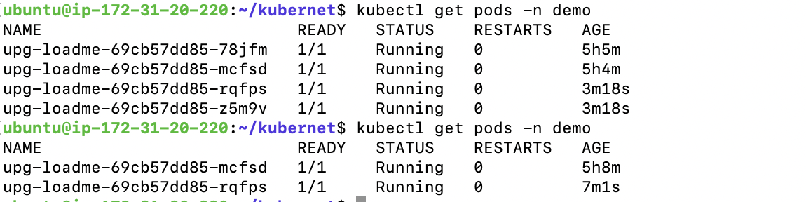

1. Screenshots of graphs showing autoscaling of upg-loadme pods and kubernetes nodes using prometheus and Grafana

